Project Development Phase
Model Performance Test

Date | 03 October 2026
Team ID | SWTID-2026-8647
Project Name | Implement Client Script & UI Policy (Incident)
Maximum Marks | 10 Marks

Model Performance Testing:
Project team shall fill the following information in model performance testing template.
S.No. | Parameter | Values | Screenshot
1. | ServiceNow UI Policy & UI Policy Actions | Incident table configuration using the High Impact Control UI Policy. The supplied evidence shows Assignment Group configured as mandatory and Urgency configured as read-only. Configuration evidence is available; functional execution result is To be verified during implementation. | 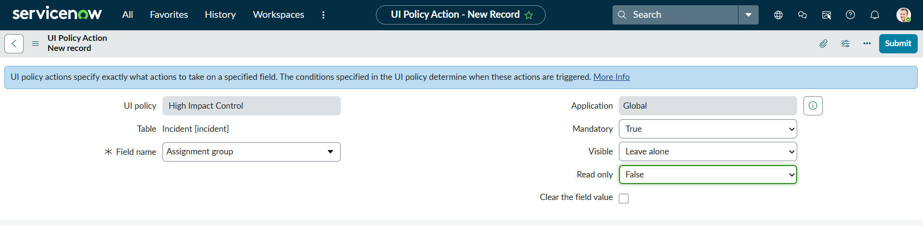  Figure 1: Assignment Group UI Policy Action  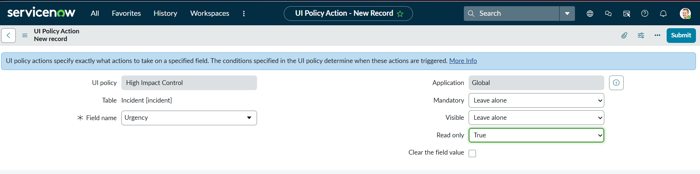  Figure 2: Urgency UI Policy Action  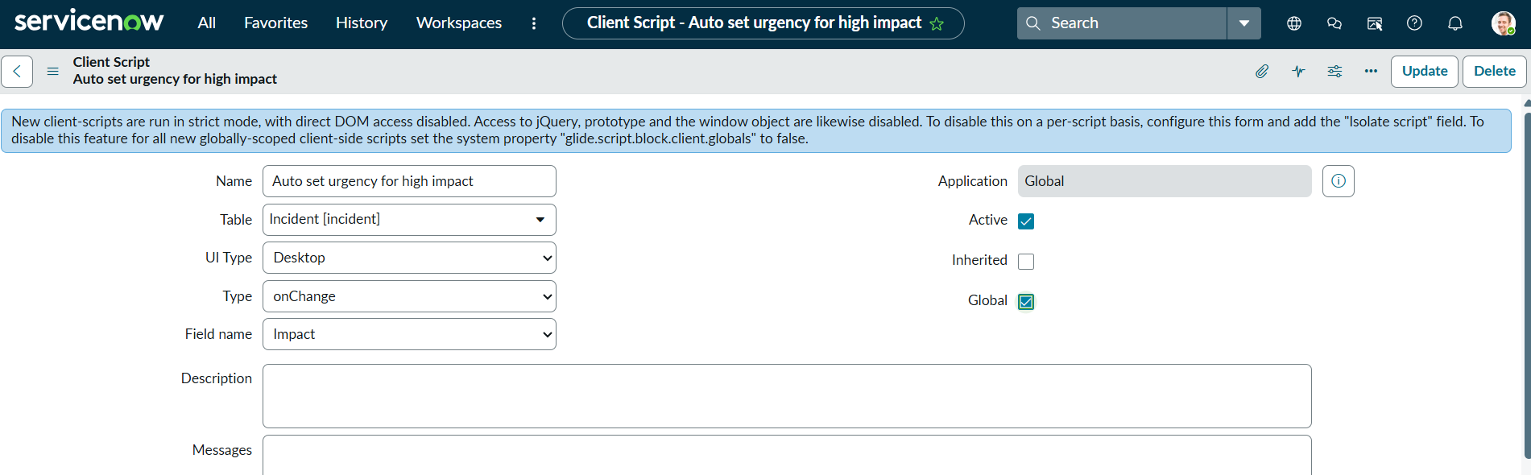  Figure 3: Auto-set Urgency Client Script configuration
2. | Client Script Configuration & Validation | Client Scripts are configured on the Incident table for client-side form behavior and validation. The supplied evidence includes an onChange Client Script for high-impact incidents, an onSubmit validation configuration, and an onCellEdit control for Incident State. Functional execution result is To be verified during implementation. | 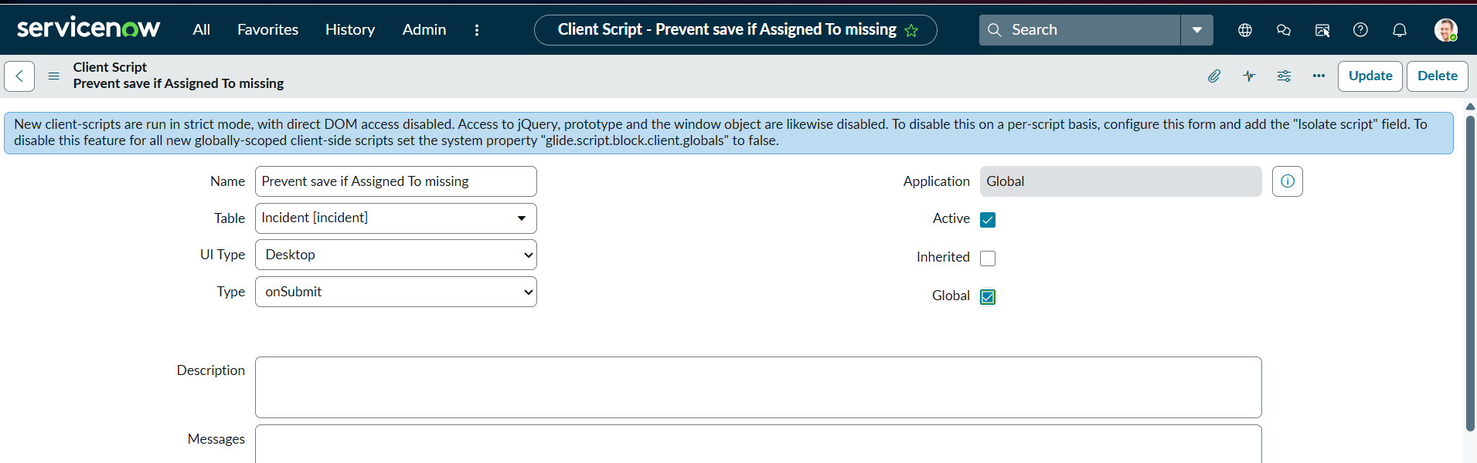  Figure 4: Prevent Save Client Script configuration  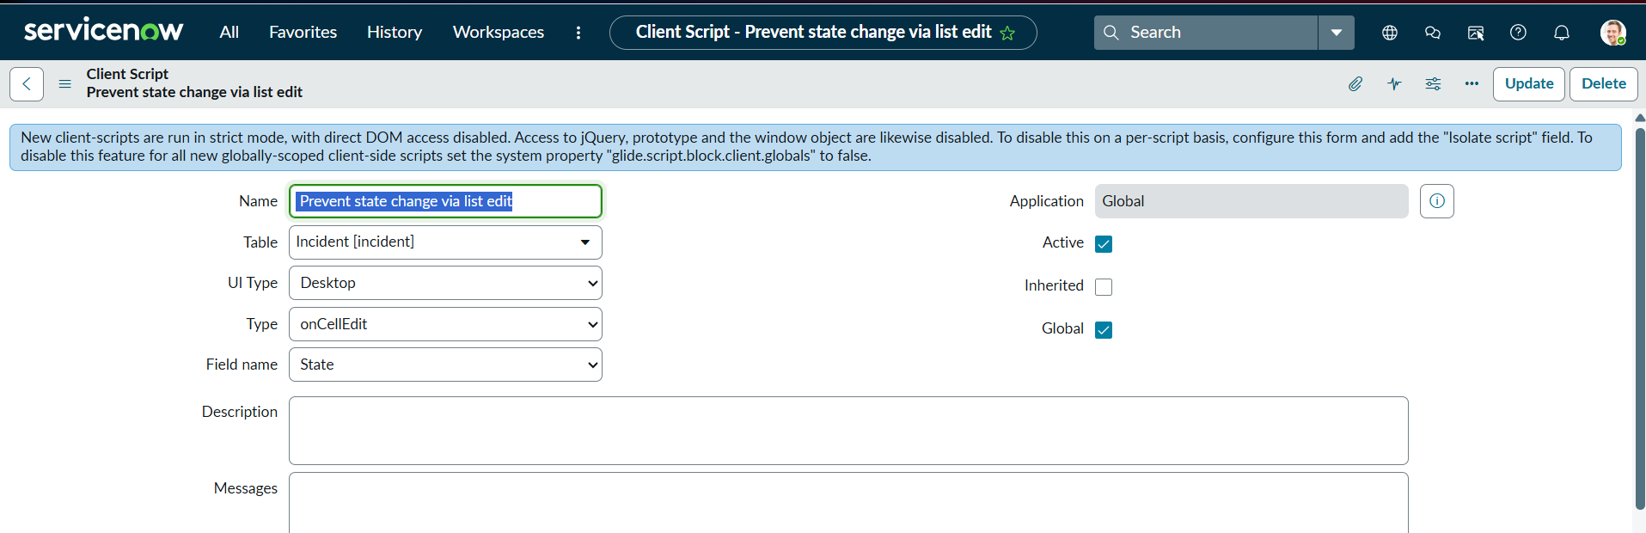  Figure 5: Prevent State Change via List Edit

